

**Title of the Research Project**

**<Student Name>**

**<Student Number>**

A report submitted for

INFO7016 Postgraduate Project A

in partial fulfillment of the requirements for the degree of

<For example, Master of ICT>

Supervisor: <XXX>

**School of Computer, Data and Mathematical Sciences**

**Western Sydney University**

<Month Year>

# ABSTRACT

If you completed a Project Proposal for INFO7016 Postgraduate Project A, then this report is a continuation of that proposal with enriched contents.

All the pages have been formatted in the accepted font and margin alignment. This is a simple thesis template that can be used for directly typing in your content. However, if you paste your text into the document, do so with caution as pasting could produce varying results. When directly typing into the title page, the appropriate information should be filled in the required fonts. This thesis template includes answers to typical questions that students need addressed before writing the thesis.

When writing an abstract, bear in mind that an abstract is a short descriptive summary of your thesis. The number of words accepted might vary, e.g. 200-300 words. Abstract is typically written last although it is the most important part of the thesis. It should concisely and succinctly articulate the essence of the report: the background, the scope of your project, the purpose, findings and conclusions. An abstract is neither paragraphed nor cited. It should not be written as a literature review or a discussion of results. In a simplistic manner, your abstract, in a few words, should answer the questions: why should we care about your research; how did you get your results; what did you learn, find, create, invent; and finally what do your results imply?

/* There are text and instructions throughout that need to be deleted when adding your own text */

# ACKNOWLEDGMENTS

You can write a formal statement to acknowledge contributions and assistance provided by others in completion of the thesis. Its customary and good manners to say thank you. The following and more have been seen in the acknowledgement of past theses: God, one’s advisor, one’s better half, parents, children, friends, classmates, lab-mates, lab technicians, lab assistants, favourable Prof, neighbours, physicians, exercise trainer(s), wiki, the maintenance guy, landlord, the school hockey team, secretary, department head …..

Keep in mind that one has to use one’s own words when writing an acknowledgement.

The present template is a revised version of the thesis template created by Clarkson University Graduate Student Association for postgraduate students ([Thesis Template - Clarkson University](https://www.google.com/url?sa=t&rct=j&q=&esrc=s&source=web&cd=1&ved=0CB4QFjAA&url=https%3A%2F%2Fwww.clarkson.edu%2Fcee%2Fgraduate%2FGSA_thesistemplate_091008.doc&ei=5hpdVcTxO8vs8AXns4OYAw&usg=AFQjCNFAajuqtsVsiU7B6LOasJ4FPNDMSw&sig2=NBbGdhCvjAsz1q4-RBFNYg&bvm=bv.93756505,d.dGc)).

# TABLE OF CONTENTS

Chapter Page

ABSTRACT i

ACKNOWLEDGMENTS ii

TABLE OF CONTENTS iii

LIST OF TABLES iv

LIST OF FIGURES v

CHAPTER I: INTRODUCTION 1

CHAPTER II: Literature Review 3

Section Header (heading 2) 4

Sub heading (heading 3) 4

Sub-sub heading (heading 4) 4

Equations 4

Tables 5

Figures 6

CHAPTER III: METHODOLOGY 8

CHAPTER IV: PRELIMINARY RESULTS (If any) 9

CHAPTER V: MORE HEADING 10

CHAPTER VI: SUMAMRY AND RESEARCH PLAN 11

REFERENCES 12

Appendix A: HEADING 13

The table of contents is most easily created automatically (!!) with REFERENCE tools within WORD. Click on the following sequence: insert, reference, index and tables, table of contents, okay. The chapter titles and section headers should have been set to create a table of contents. It is important that the styles laid out in this template are used to maximize the benefits of the template and MS WORD options. The table of contents can be updated as you revise your thesis by using right mouse button and clicking on “update field”. With this approach, there is no need to copy and paste or retype your chapter and section titles.

# LIST OF TABLES

Table Page

Table 1: Steps in creating a table 5

Table 2: Styles used in this template 7

The list of tables is also easily created automatically (!!) with REFERENCE tools within WORD. Click on the following sequence: “insert, reference, index and tables, table of figures, (find “caption label” box set as – tables), okay”. This can be updated as you revise your thesis by using right mouse button and clicking on “update field”. With this approach, there is no need to copy and paste or retype your chapter and section titles. You need to also use the table captions within the body of your thesis (see examples below). The insertion of table captions in this manner also helps because word automatically renumbers the tables within the text when you insert another table in the middle. There is no need for you to renumber the tables manually

# LIST OF FIGURES

Figure Page

Figure 1: Example photo with high resolution. Caption created with “insert, reference, caption, figure” and the style changed to “thesis-figure caption”. 6

Figure 2: Example of high resolution graphic inserted with “paste special, as enhanced metafile” 6

The List of Figures is most easily created automatically (!!) with REFERENCE tools within WORD. Click on the following sequence: insert, reference, index and tables, table of figures, (find “caption label” box set as – Figures), okay. This can be updated as you revise your thesis by using right mouse button and clicking on “update field”. . With this approach, there is no need to copy and paste or retype your chapter and section titles. You need to also use the figure captions within the body of your thesis (see examples below). The insertion of figure captions in this manner also helps because word automatically renumbers the tables within the text when you insert another table in the middle. There is no need for you to renumber the figures manually

# CHAPTER I: INTRODUCTION

/* Begin typing or pasting the rest of your chapter 1 text here; and then deleting the instructions below */

The headings of chapters should be in bold capital of font size 14.

The main goal of your introduction is to identify a problem that is worthy of investigation. It must also provide some ideas of your research goals and approach to research. Specific objectives can be introduced in the introduction chapter or they can be saved for later after you’ve provided additional background on the topic and state of the current research and its gaps. The Introductory chapter often concludes with a summary of the organization of the thesis, including identification of the general content of specific chapters and appendices.

Ideally, chapter one defines the overall importance of the problem areas and provides an introduction into what you did, chapter two is why you did it in the context of what was previously known, three is how you did it, four is what you found and five is what it all means – putting the pieces together, (what’s your contribution to the research field).

It should be noted that the objectives of your research define the OUTCOME, i.e. what will be learned. They are not a statement of the approach or tasks that are required to meet these objectives. Some examples of reasonable research objectives:

* Determine the effect of Marangoni convection on mixing of molten glasses
* Predict the extent of mechanical degradation of polymers

These both define the resulting outcome (prediction, effect on…) so they are objectives. The related tasks or research approach could be:

* Solve a set of coupled non-linear PDEs…
* Perform experiments on…

These define the required steps; they do not define the outcome so they are NOT objectives.

This template uses the MS WORD STYLES extensively to help keep your work in the proper format. These paragraphs use the “thesis-body text” style that is set for Times New Roman, 12 point font with double spaced lines and extra spacing between paragraphs (no need for hard carriage returns). There are also styles for headers, equations, captions and bulleted lists that you can choose to use. See examples throughout this template.

# CHAPTER II: Literature Review

The above is a suggested heading for this chapter. Individual authors may chose appropriate heading for the literature review chapter.

Literature review is an essential part of research methodology. This chapter needs to provide sufficient fundamental background information about the subject to justify your objectives, provide rationale for your hypothesis (or research questions) and support you research methods, Review the pertinent literature related to the specific problem/hypothesis you are addressing. The literature review may cover:

* what are the fundamental science, math, engineering concepts related to your research (scope),
* what part of your research work has ever been investigated before and what has not, (some of this may have been included in the introduction)
* how does your research work relate to that done by others,
* how have others defined/measured/identified the key concepts of your research,
* what data sources have you used or have other researchers used in developing general explanations for observed variations in a behaviour or phenomenon in a concept in your thesis etc.

The literature review should not be limited to the above questions only.

Bullets can be single spaced. The above bullets are in the style “thesis-bullets”. When you type bulleted text, highlight the bulleted text and then select “thesis-bullets” from under the format, style menu to automatically change their formatting as above.

## Section Header (heading 2)

The section header should have capital lead letter of each word.

Given the length of each chapter, it is required to use headers and sub headers (possibly sub-sub headers). These can be numbered or one can just rely on different formats. The section headers in this document are labelled “heading 2” (“heading 1” was used for chapter titles). The heading styles formats should be consistent throughout the document as it helps significantly in creating the automatic table of contents.

### Sub heading (heading 3)

The subheadings here have the style of sentence case. than the section headers.

Sub-sub heading (heading 4)

You can even get to another level of headers, defined here as “heading 4”. The table of contents, however, is currently set up to just include three levels of headers.

### Equations

Equations can be created in MS WORD equation editor or they can be created with other software. Equations should be numbered. They can be numbered within each chapter (e.g., 2.1, 2.2) or they can be numbered sequentially throughout the entire thesis. A caption can be created for equation numbering, for example, ‘(’ or ‘(2’. Can be created as captions then used for equation numbering. Equations should be indented or centred with the equation number to the right. The example below and associated “thesis-eqn” style can be used for all your equations.

|  |  |
| --- | --- |
| $$y=A\sin\left(ωt\right)$$ | (2.1) |

where ‘(2.’ is a created caption. Number ‘1’ is automatically assigned by WORD and ‘)’ is added as a caption content. The reason for placing the equation and the equation number in a two column table is for the convenience of cross referencing later. The borders of the equation table can be masked by selecting ‘No borders’ in “Table Tools”, “Design” menu. A clean equation is shown as follows

|  |  |
| --- | --- |
| $$\frac{dy}{dt}=Aω\cos\left(ωt\right)$$ | (2.2) |

When this equation is cross referenced, simply type ‘Eq.’, then go to “Cross-reference” under “References” menu, select ‘(2.’ In “Reference type” and insert the entire caption ‘(2.2)’, you will get Eq.(2.2).

### Tables

Tables should have meaningful information with descriptive headers. You can use the “thesis-table caption” style to define your captions and refer to the table in the text with a “cross reference” (Table 1). MS Word re-numbers table captions automatically when new tables inserted. But you need to right click on any cross references and “update field” if there are changes.

Table 1: Steps in creating a table

|  |  |
| --- | --- |
| **Step #** | **Instruction** |
| Create table caption | Insert, reference, caption, table |
| Format the caption | Format, style, “thesis-table-caption” |
| Create table | Table, insert… |
| Format the table | The formatting of the table can vary, including use of single space as appropriate. Most journals require that tables are formatted using table style “Table Simple 1” format. |
| Reference the table from the text | With the cursor at the location you want to cite the table: insert, reference, cross reference, table, label and number only. |

### Figures

Figures and illustrations are a necessary means of communicating technical information. Often times, figures included in the background/literature review section are copied from existing copyrighted information. In all cases, this is technically inappropriate without also receiving permission from the copyright owner. Citing the source of the figure is not sufficient.

Resolution of figures is often a problem in theses. Resolution should be >300 dpi, preferably 600dpi (Figure 1). You should note that saving images as jpeg files is a sure way to lower the resolution to an unacceptable extent. From experience, a good way is to copy your graphic (for example from PowerPoint or excel) and when pasting it into word, use the “paste special” “as an “enhanced metafile” (Figure 2). This also substantially reduces the resulting file size in comparison with pasting graphs in as excel graphics.

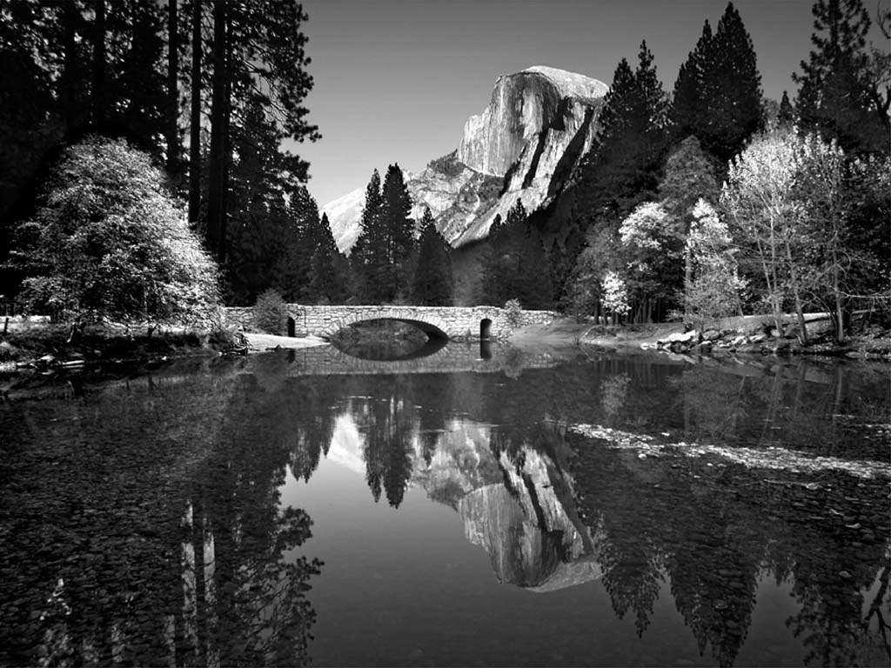

Figure 1: Example photo with high resolution.



Figure 2: Example of high resolution graphic inserted with “paste special, as enhanced metafile”

# CHAPTER III: METHODOLOGY

The above is a suggested heading for this chapter. Individual authors may chose appropriate heading for the chapter to describe the research methodology.

In addition to the detailed methods you need to describe in this section, you need to provide specific objectives and an overview of your approach if they have not already been presented in the introductory chapters. The best place to put those items can vary among theses. Sometimes the background and literature review is really necessary to justify and substantiate the specific objectives and approach and, therefore, it is best to save those details for the beginning of this chapter.

These paragraphs are in “thesis-body text”. Other styles including captions, headers etc. can be used as presented in the previous chapter. Table 2 summarizes all of the styles that can be used with this template.

Table 2: Styles used in this template

|  |  |
| --- | --- |
| Style name | When used |
| Heading 1 | Chapter titles |
| Heading 2 | Primary headers |
| Heading 3 | Sub headers |
| Heading4 | Sub-sub headers |

# CHAPTER IV: PRELIMINARY RESULTS (If any)

The above is a suggested heading for this chapter. Individual authors may chose appropriate heading for the chapter to describe the research results.

You might have conducted preliminary or limited experiments/simulations/field surveys. If so, you may include such results, findings, discussion of results OR manuscripts. It is best to also reiterate information in your literature review to help substantiate the findings of your research. If result section is presented separately from a discussion section, the factual results of your research will be presented in this section. Information may be presented in tables or figures (i.e. graphs, diagrams, maps, photographs, etc.); however, these illustrations should not stand alone. An explanation of the relevant findings must be included. The results may be structured around the questions, hypotheses or themes. The discussion should draw together the findings from your research and relate it to the literature or current knowledge of the topic. It should make sense of, or explain, what you have found and discuss what your findings mean.

This template is best used for directly typing in your content.

# CHAPTER V: MORE HEADING

The author may add more chapters.

# CHAPTER VI: SUMAMRY AND RESEARCH PLAN

You may summarise what you have done so far in Master Project 1 and describe the research plan for INFO7017 Postgraduate Project B.

# REFERENCES

Include all references: articles, media facts, books, reports, regulations, internet articles, papers that you referenced from the text. You need to use HARVARD referencing style. In the text, citations can be (Smith and Jones, 2007) or Smith et al., 2007) (if more than two authors) if you wish to present your references alphabetically. The computer software “EndNote” or the MS WORD tools – “insert, reference, footnote, endnote” (or “cross reference” if you refer to the same reference more than once) should be used to help you organize and manage your references.

References can be written in single space with extra space between references as in the format below. There are many different ways to arrange the information and punctuation in a reference listing. The most important thing is to make sure all references are complete and that the format of your references is consistent throughout. If you have questions about referencing, on-line librarians can provide instant assistance at <http://library.uws.edu.au/citing.php>.

Example, S.Z. (2008). How to cite a complete journal reference. *J. Complete Thesis*. 1(2): 47-52.

Example, S.Z., Second, W.S. (2007). How to cite a complete conference proceedings paper. In: *Proceedings*, 2nd International meeting of Masters Students, Paper # XW15 (Potsdam NY, November, 2007).

If you use the “thesis” reference” style you will get the proper line spacing and indent style without further changes. Above are examples to show complete citation, other formats also acceptable.

# Appendix A: HEADING

Type or paste your appendices here. Appendices are a place to organize and include all of the “extra” material that is important to your research work but that is too detailed for the main text. Examples can include: specific analytical methods, computer code, spreadsheets of data, details of statistical analyses, etc. But, these materials do not speak for themselves. There should be a reference to these materials from the main chapters (complete details included in Appendix A) and there should be some text at the beginning of each appendix to briefly explain what the information is and means that is included in that appendix.